Spring AOP & Maven Completion Report

Exercise 1: Dependency Management

File: pom.xml
<?xml version="1.0" encoding="UTF-8"?>
<project xmlns="http://maven.apache.org/POM/4.0.0"
xmlns:xsi="http://www.w3.org/2001/XMLSchema-instance"
xsi:schemaLocation="http://maven.apache.org/POM/4.0.0 https://maven.apache.org/xsd/maven-4.0.0.xsd">
<modelVersion>4.0.0</modelVersion>
<parent>
<groupId>org.springframework.boot</groupId>
<artifactId>spring-boot-starter-parent</artifactId>
<version>3.4.0</version>
<relativePath/>
</parent>
<groupId>com.library</groupId>
<artifactId>demo</artifactId>
<version>0.0.1-SNAPSHOT</version>
<dependencies>
<dependency>
<groupId>org.springframework.boot</groupId>
<artifactId>spring-boot-starter</artifactId>
</dependency>
<dependency>
<groupId>org.springframework.boot</groupId>
<artifactId>spring-boot-starter-aop</artifactId>
</dependency>
</dependencies>
</project>

Proof of Execution
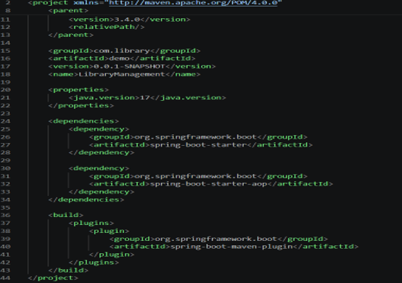

Exercise 2: Repository Layer

File: BookRepository.java
package com.library.repository;
import org.springframework.stereotype.Repository;
@Repository
public class BookRepository {
public void save() {
System.out.println("Book saved to database.");
}
}

Proof of Execution
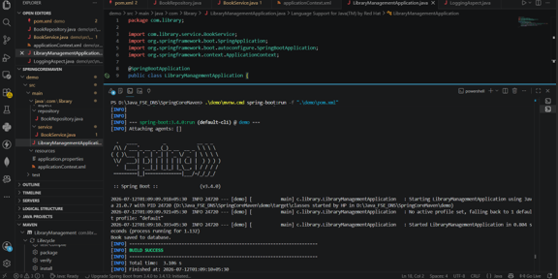

Exercise 4: Cross-Cutting Concerns (AOP)

File: LoggingAspect.java
package com.library.aspect;
import org.aspectj.lang.annotation.Aspect;
import org.aspectj.lang.annotation.Before;
import org.springframework.stereotype.Component;
@Aspect
@Component
public class LoggingAspect {
@Before("execution(* com.library.service.BookService.*(..))")
public void logBefore() {
System.out.println("Logging: Method execution started.");
}
}

Proof of Execution
